**Assignment No. 3** Truta David Cristian

**graph1k:**

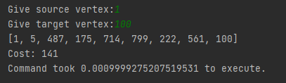 **1-100:**

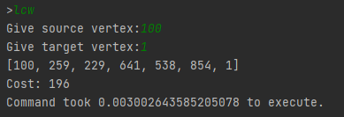

**100-1:**

**graph10k:**

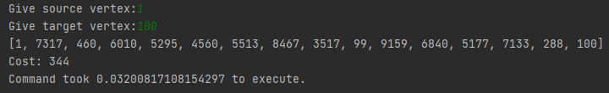 **1-100:**

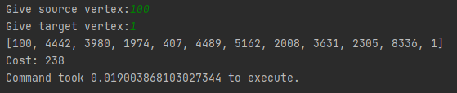**100-1:**

**graph100k:**

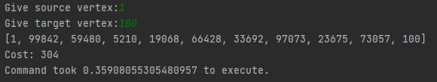 **1-100:**

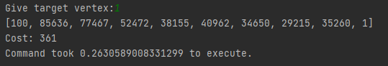 **100-1:**

**Manual executions:**

